Crypto & Stock Anomaly Detection System
Database Systems (Lab)



Submitted by: Abdul Haseeb & Abdul Samad
Submitted to: Sir Ali Hassan

Semester: IV - BSSE (Group-A)
Course Code: CSC 451
Session 2024 –2028 (Fall)

INSTITUTE OF MANAGEMENT SCIENCES
HAYATABAD, PESHAWAR (2025)

Topic | Version | Prof Remarks | Date
ERD & Schema | Version 1.0 |  | April 25, 2026

Entity Relationship Diagram (ERD)

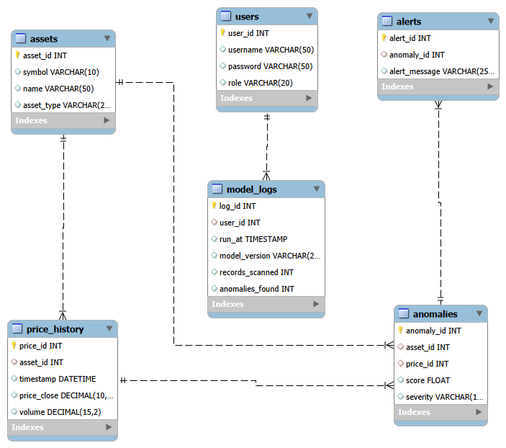

Relational Database Schema

Table Name | Attributes | Keys | Description
assets | asset_id, symbol, name, asset_type | PK: asset_id | Stores metadata of tracked assets
price_history | price_id, asset_id, timestamp, price_close, volume | PK: price_id, FK: asset_id | Historical OHLCV data
anomalies | anomaly_id, asset_id, score, severity | PK: anomaly_id, FK: asset_id | Records detected anomalies
alerts | alert_id, anomaly_id, alert_message | PK: alert_id, FK: anomaly_id | Notification logs
users | user_id, username, password, role | PK: user_id | System access control

Relationship Summary
The system utilizes a normalized relational schema where the assets table serves as the primary entity, linked to price_history and anomalies via Foreign Key constraints to ensure data integrity.
The integration of the users and model_logs tables demonstrates a clear audit trail, where each model run is mapped to the specific user who executed it.

